Practical Lab File

Semester – I
Lab-I : CAMS1P01

Master Of Computer Applications

Aligarh Muslim University
(DEPARTMENT OF COMPUTER SCIENCE)

Submitted By: Submitted to:
Shivangi Prof. Arman Rasool Faridi
GN4485 Dr. Faraz Masood
26CAMSAG140 Mr. Maaz Shamim
Mr. Khushnood Bilal

Week#1
Fundamentals of IT: MS Word and MS Excel
Problem 1. Open a new document and type the following letter.
- Save the document as “Letter.doc.”
- Send the document to 3 recipients using Mail merge. (Use 3 different addresses)
- Define a Macro “Decorate” which makes the text bold, Red in color and italic, font size Assign
- a shortcut key Alt + Z to this macro.
- Close the document.
- The Sample Addresses are:
  - Mr. Amit Tandon, 13, New Estate, Ring Road, Chandigarh
  - Mr. Rohit Saluja, 15, Karol Bagh, New Delhi
  - Ms. Jyoti Parmar, Sector 16, New Building, Gurugram.

Steps:
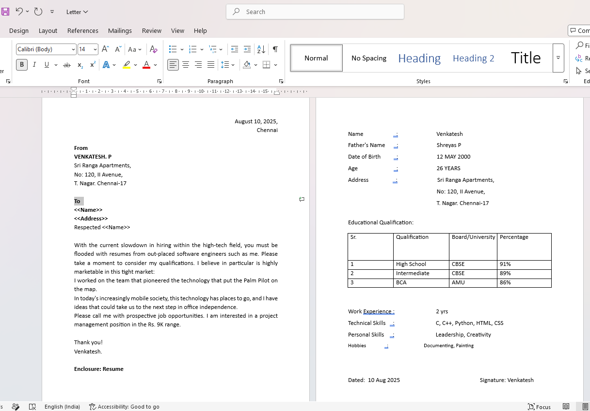
- Open a new MS Word file and type in the following letter and along with the enclosed resume. After that save the document as “Letter.docx”

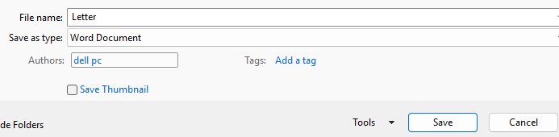
- Mail Merge:
- Go to the Mailings tab and click on the Start Mail Merge drop down button. From there select Step by Step Mail Merge Wizard.
- Select the Letters document type to work on and click on Next: Starting document to go to the next step.
- Next select the document which has to mail merged. Here we choose the current document. Click on the Next: Select recipients.
- Now we'll type in a new list of the recipients. A new window appears to Edit data Source.
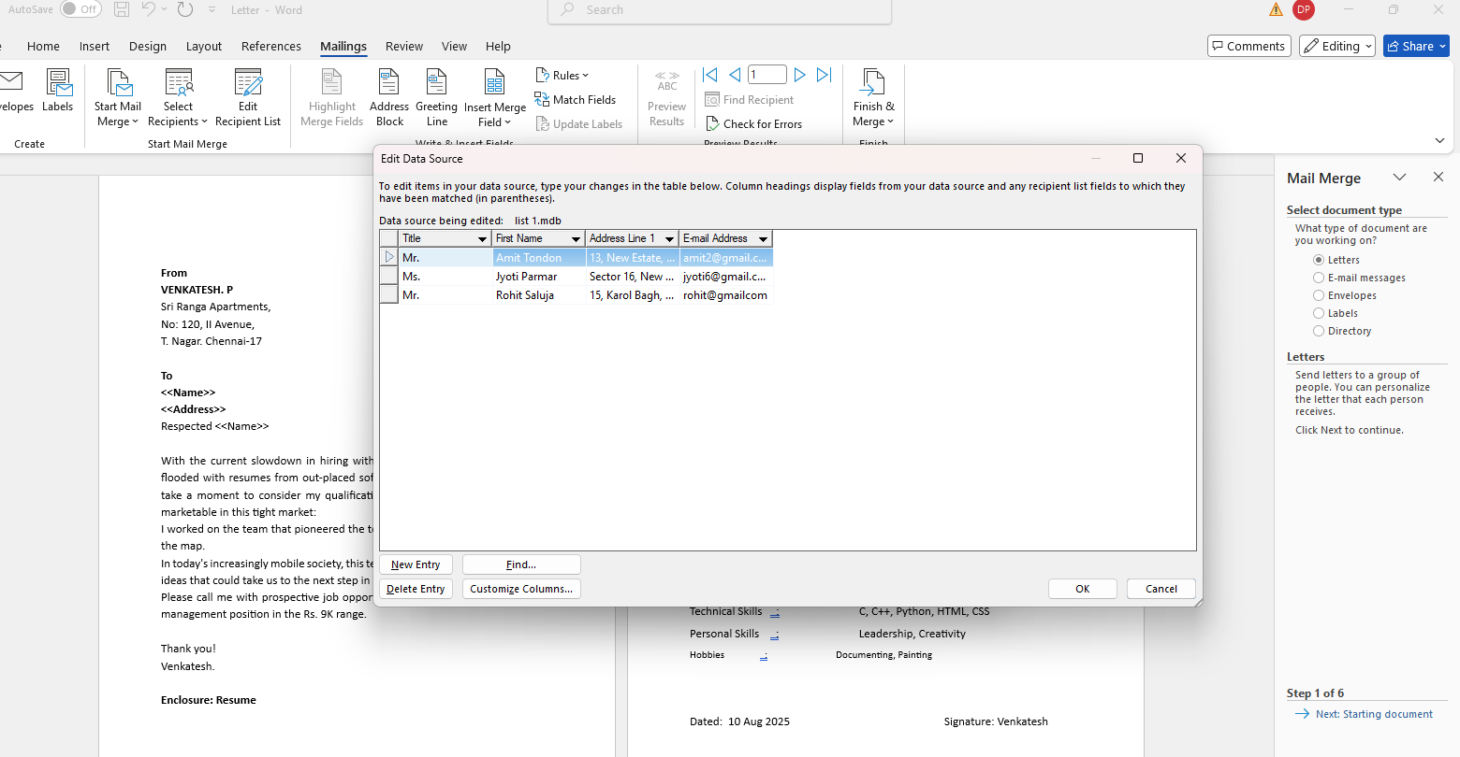
- Customize columns as needed and type the fields for the data that has to be entered of the recipient. And then click on Next: Write your letter.

- Now on the letter which has been written already, select the fields that you want to insert by placing the cursor at the required place.
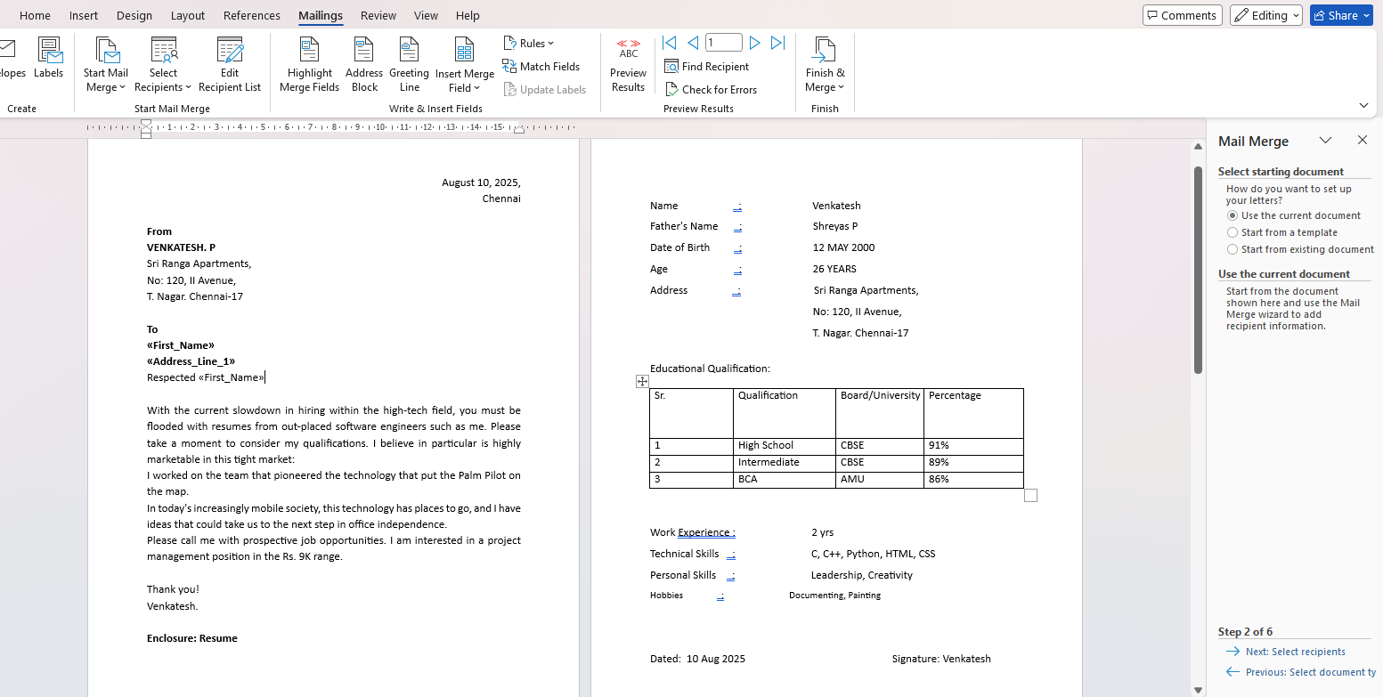
- You can see that the fields you inserted would appear like «AddressBlock», «Title», «FirstName» and so on. Now click on Next: Preview your letters at the bottom.

- Here, all the letters can be individually previewed. This is how
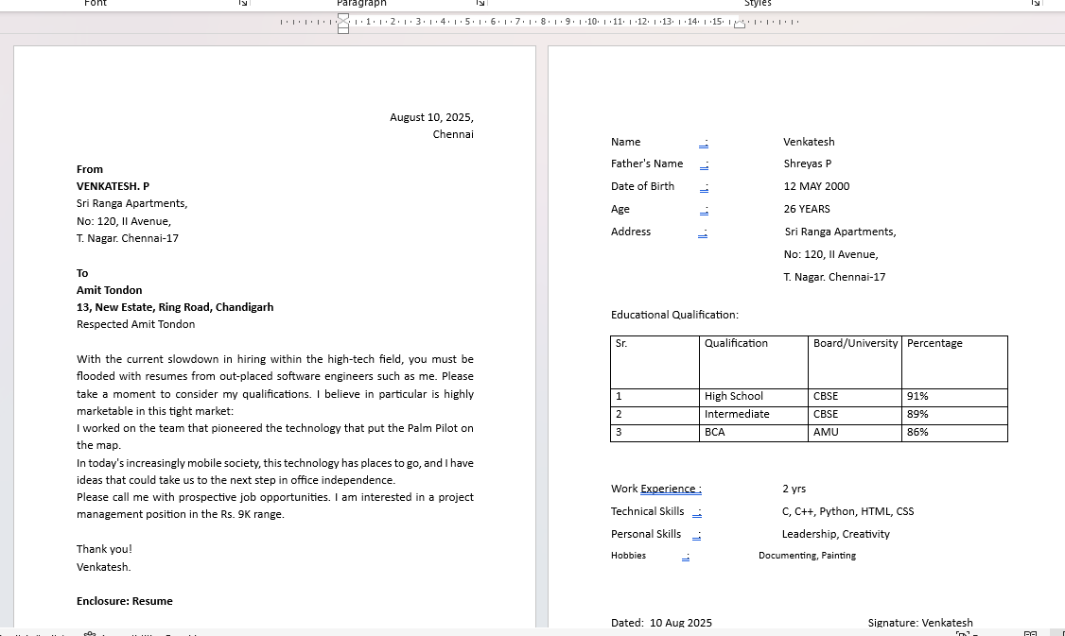
mail merge is done. For the first recipient the result is shown below:

- Creating a macro:
- Open a word document and go to the View tab. Click on the Macros dropdown button and select Record macro.
- A new window appears for recording a macro. Here, set the macro name as Decorate. After this select the keyboard icon.
- Assign the shortcut key as Alt+Z. Close the dialog box
- Press Ctrl+D to open the dialogue box for editing and applying the macro and select BOLD, ITALIC and RED font color.
- Once again go to the View tab. Click on Macros and then click on Stop Recording.
- Now click on View Macros. A new window appears which has the saved macro. Select DECORATE and click run.
- Select all the text and then use the assigned key Alt+Z. We get the desired result.

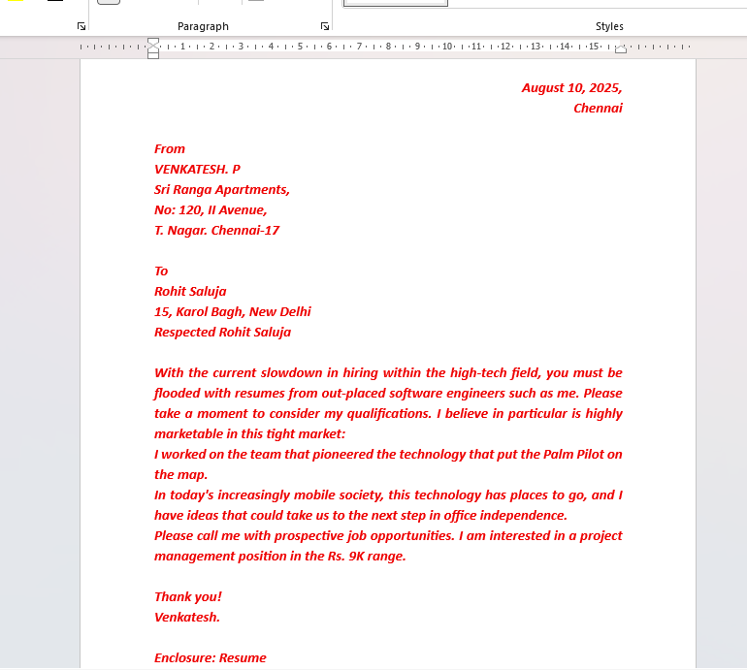
Problem 2 : Create a table as shown below:
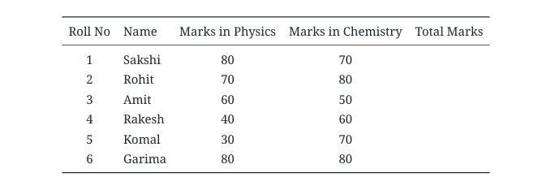

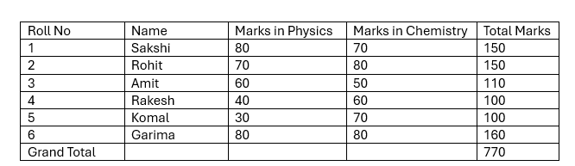

- In the total marks’ column, entries should be calculated using formulas and it is the sum of marks in physics and marks in chemistry.

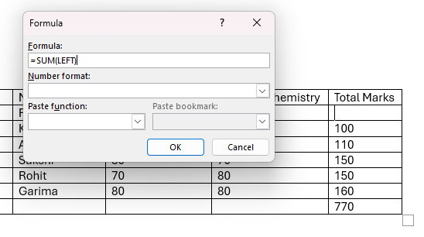
- Insert a new row at the end of the table and also find grand total using formula.

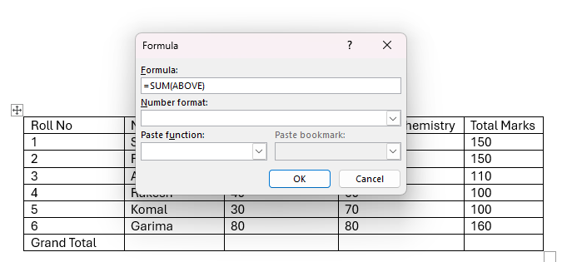

- Sort the table based on total marks.
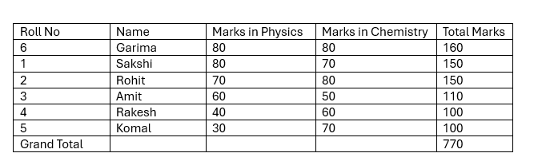
- The date and heading should be centre aligned.
- Heading should be in bold and underlined.
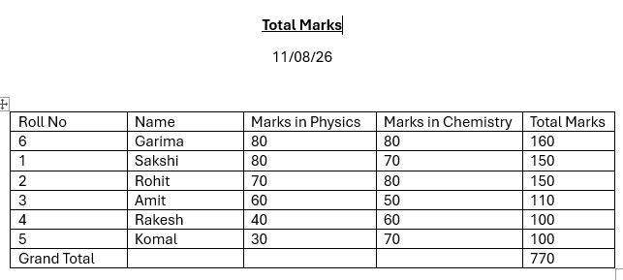
Problem 3: Using a spreadsheet package you have studied, construct T Morongo’s pay slip for December 2016 following the instructions below. Insert a custom footer with your name, subject, course, exam/Test & question number. Save it as Salary advice.
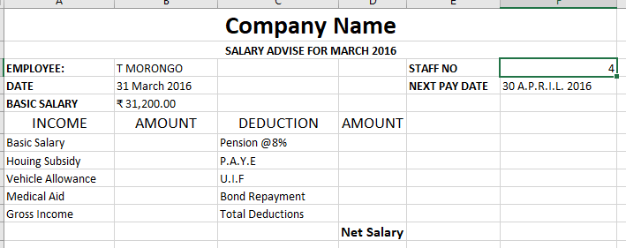

Instructions
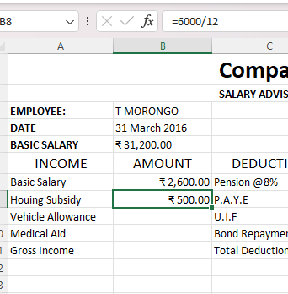
- Housing Subsidy 6000.00 per year.

2. Car Allowance 100.00 per month.
3. Pension 8% on Basic Salary.
4. PAYE 636.83.
5. Medical Aid 70.00.
6. U.I.F. 1% on Basic Salary + Housing Subsidy.
7. Bond Repayment 630.00.
8. Calculate Net Salary.

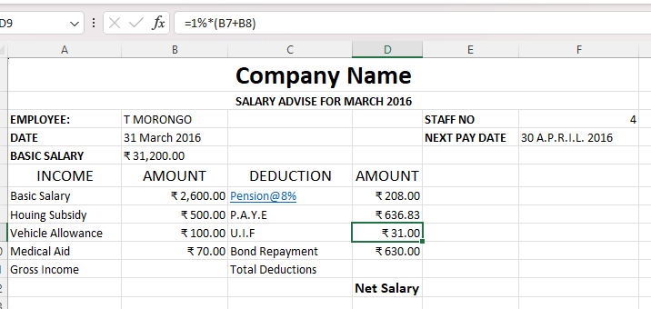
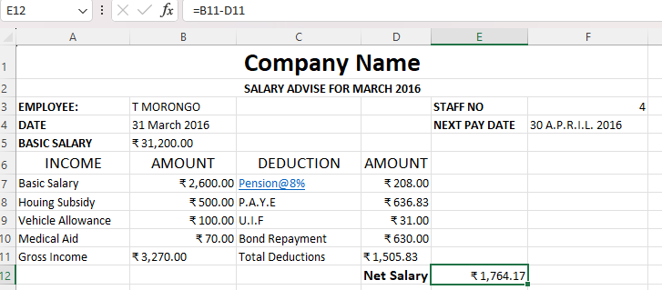
9. Format all figures to two decimal places and insert ₹ currency symbol.
10. Insert a custom footer with your name, subject, and question number. Save it as salary
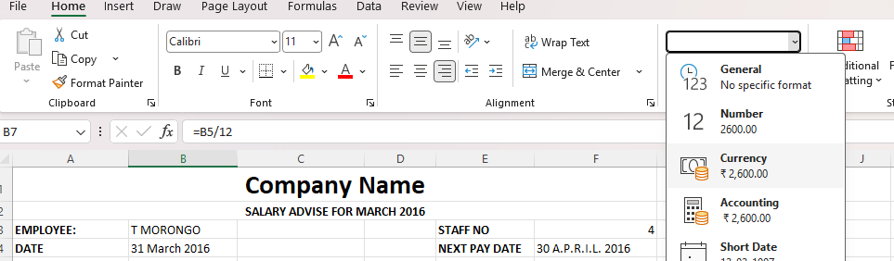
advice2.
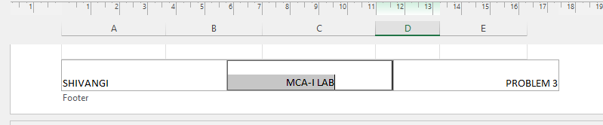

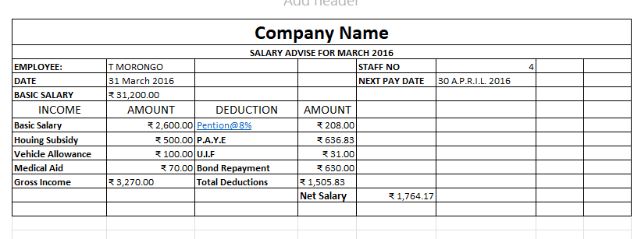

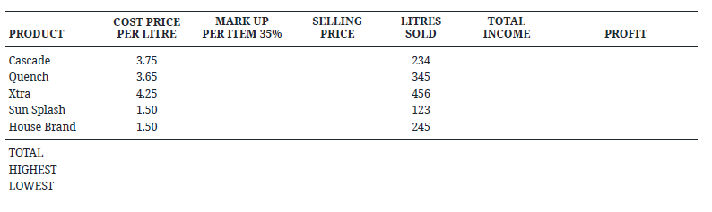
Problem 4. Use a new workbook & construct a worksheet with the data given & save it as LYONS.

Instructions
- Markup = Cost price/Litre x 35%
- Selling price = Cost price/Litre + Mark up
- Total income = Litres sold x Selling Price
- Profit = Total income - (Cost price/Litre x Litres sold).
- The MARKUP % (35%) must be inserted in a separate cell under the heading. USE IT as an absolute cell reference in the formula to calculate the mark up per item.

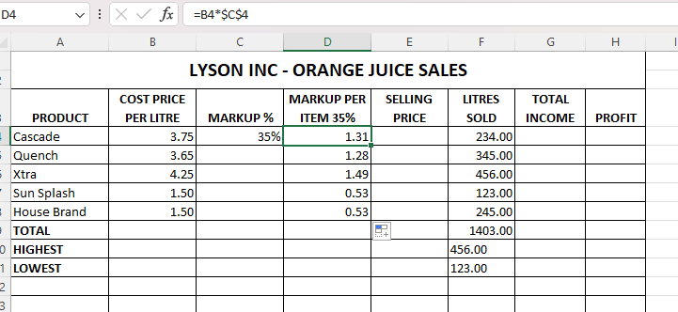
- Calculate the mark up for each item.

- Calculate the selling price for each item.

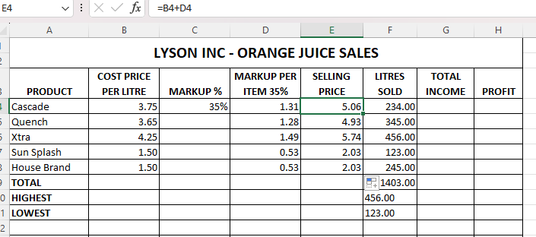

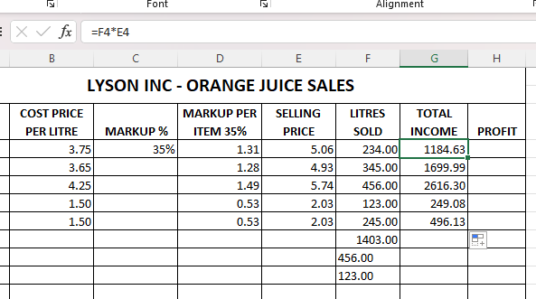
- Calculate the Total Income for each item.

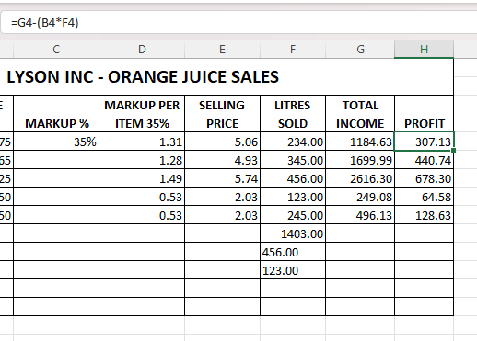
- Calculate the profit for each item.

- Format the column LITRES SOLD to display the number of litres as integers. The rest of the worksheet must be formatted to display two decimals.
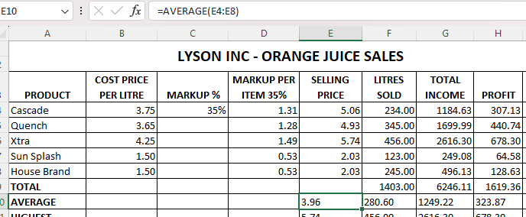
- Use statistical functions to calculate the AVERAGE, HIGHEST (MAX.) and LOWEST (MIN) for Selling Price column up to Profit Column.

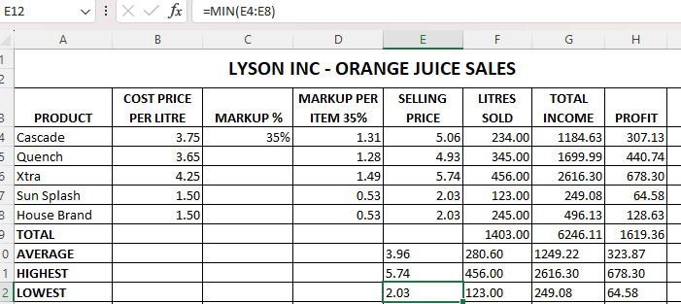
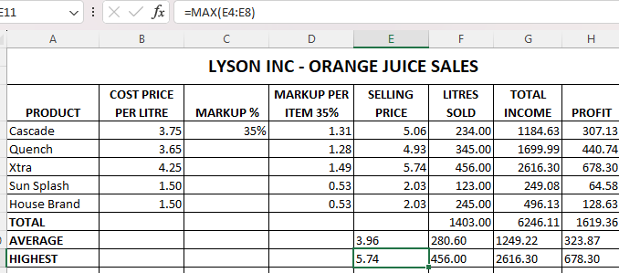

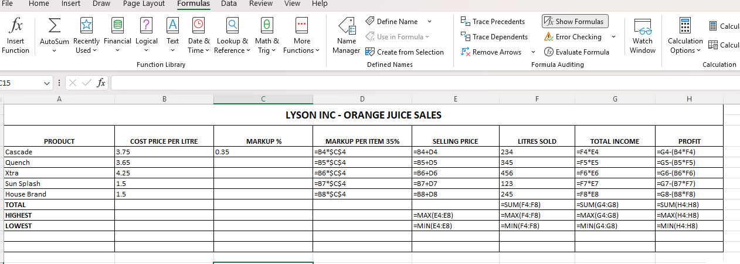
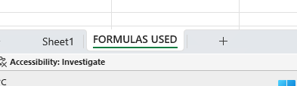
- Show all formulas you have used in a new sheet. Adjust the column width so that the formulae are displayed in full and the sheets fits into one side of A4 landscape format and save it as formulas.

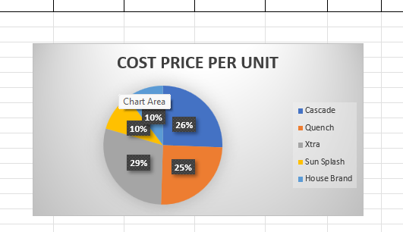
- Under the worksheet Create a pie chart titled PRODUCT COST PER UNIT for Product & Cost price per Litre columns. Data labels indicating percentages should be displayed.

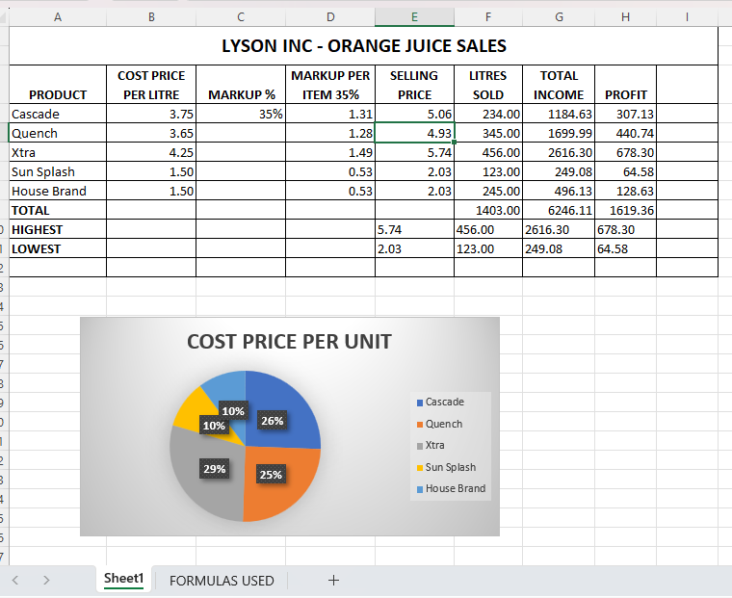
- Put borders neatly on the on the work sheet & save it as LYONS2.
WEEK #2
Fundamentals of IT: MS PowerPoint
- Design Seasonal Greeting cards using MS-PowerPoint.

2. Design an AMU Magazine cover in MS PowerPoint. Use the following:
i) Select a theme for the page.
ii) Insert either a picture or clipart.
iii) Use WordArt.


3. Design a poster inviting all students of your department to the IT Fest (using MS-Power

Point).

4. Create a 5-slide presentation on any topic. Use Images, Graphs, Chart, Tables, Animation,
Time, Bullets, Transition, Sound, Hyperlink, Background template, Header and
Footer (using MS-Power Point).

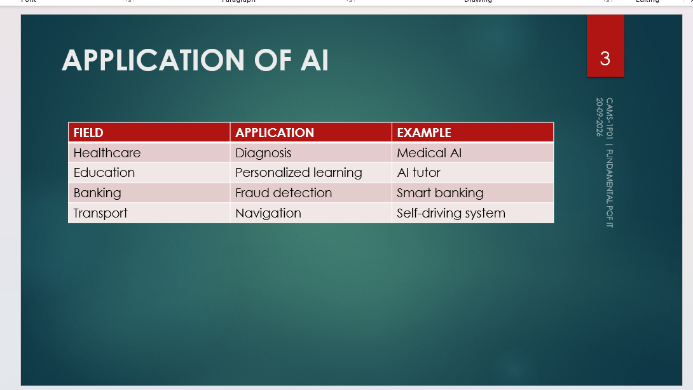





- Create a 5-slide presentation on any topic. Use Images, Graphs, Chart, Tables, Animation, Time, Bullets, Transition, Sound, Hyperlink, Background template, Header and Footer (using MS-Power Point).

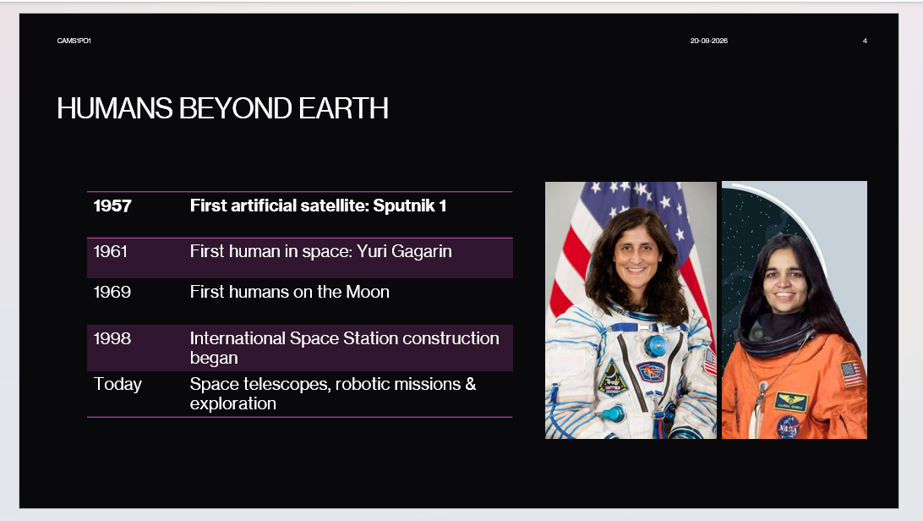
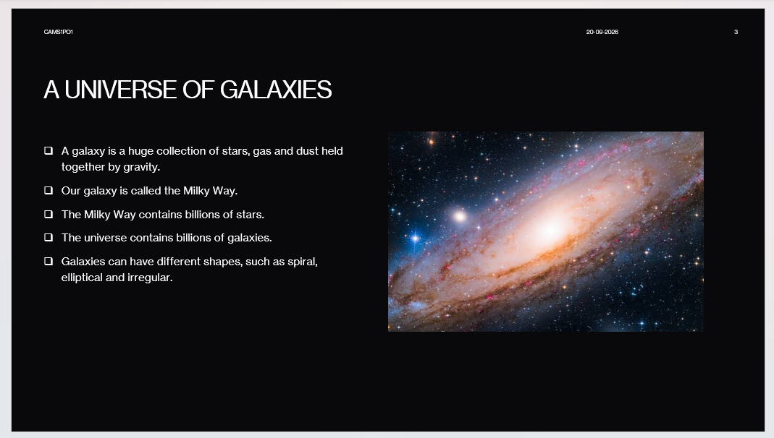
WEEK #3
C++ Environment, IDE Installation and Tool Setup
Section 1.02 Installing and Configuring C++ IDE
We can get the appropriate installable for dev-C++ IDE from http://www.bloodshed.net/
dev/devcpp.html Let’s see the entire installation process now. We have used the installable
that comes along with the C++ compiler. In this tutorial, we use the dev-C++ version 5.11
with the TDM-GCC 4.9.2 compiler. The stepwise installation for dev-C++ is given below.
1. The first step while we start the installer is to select the language of our choice as shown
in the below screenshot.
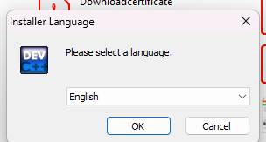

2. Once you select the appropriate language, you have to agree to the license agreement
that pop-ups next.
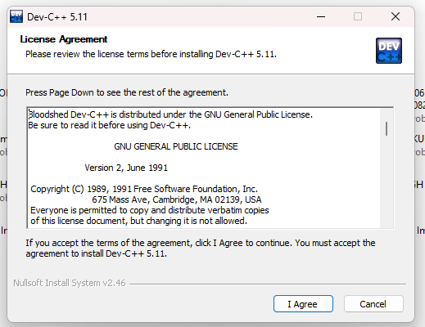
3. Next, we are asked to select the components that we need to install as a part of the dev-C++ installation. As shown in the above screenshot, we are provided with a list of components available for installation and a checkbox against each component. We can check/uncheck each box to indicate which components to install. Click next once the components are selected.
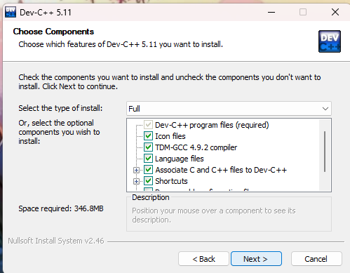

4. Now the installer prompts the user for the destination folder where the dev-C++ files/libraries etc. are to be copied. Once we provide the destination folder path, click on Install.
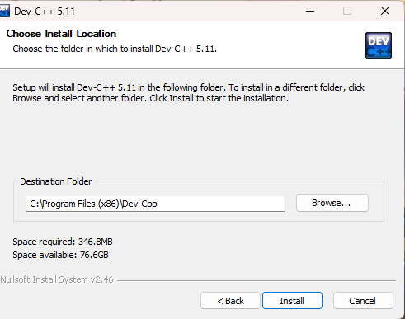

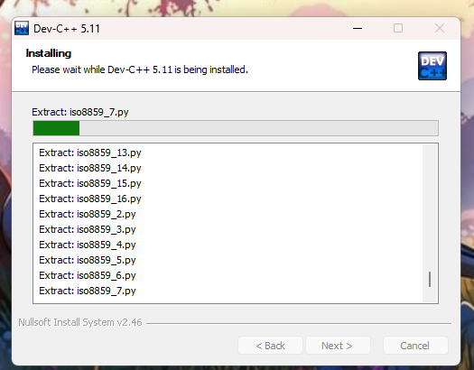
5. The following screenshot shows the progress of the installation. Once the installation is over, a “finish” dialog that signals the end of the installation appears. We click finish and then we can launch the dev-C++ IDE. Now let’s see the working of this C++ IDE in detail.

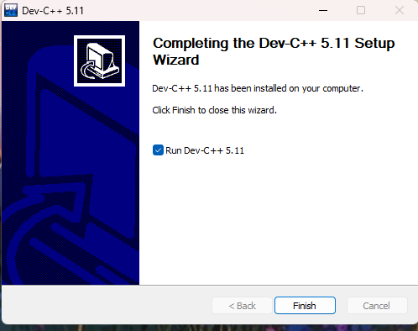
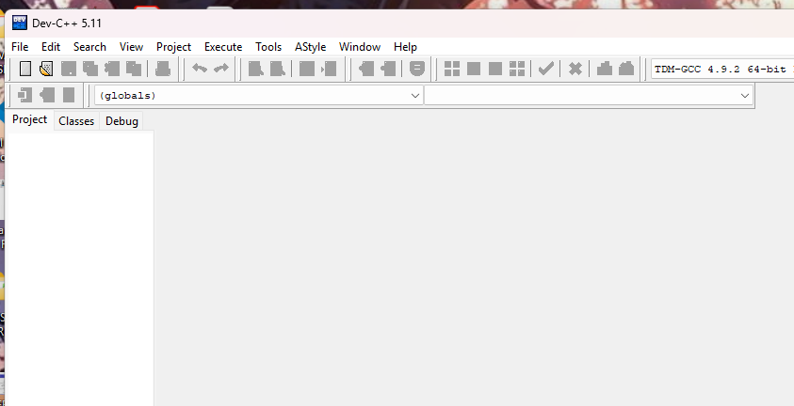
Development Using Dev-C++ IDE.

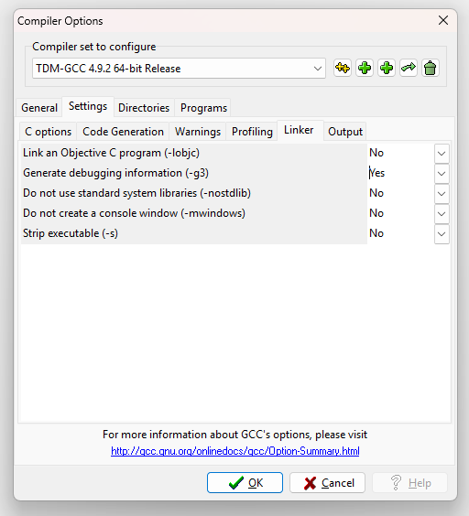
- Configuring Dev C++
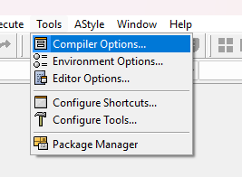
- Change Linker Setting for Debugging.

- Create a New Project
- Add Source File(s)
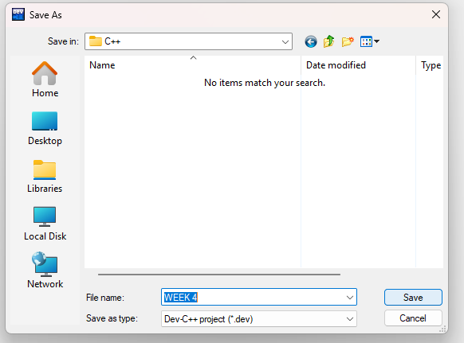
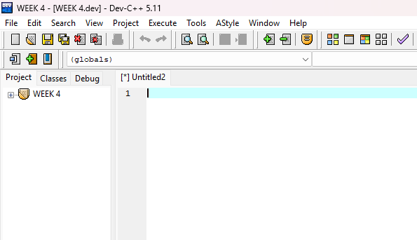

- Compile/Build & Execute Project
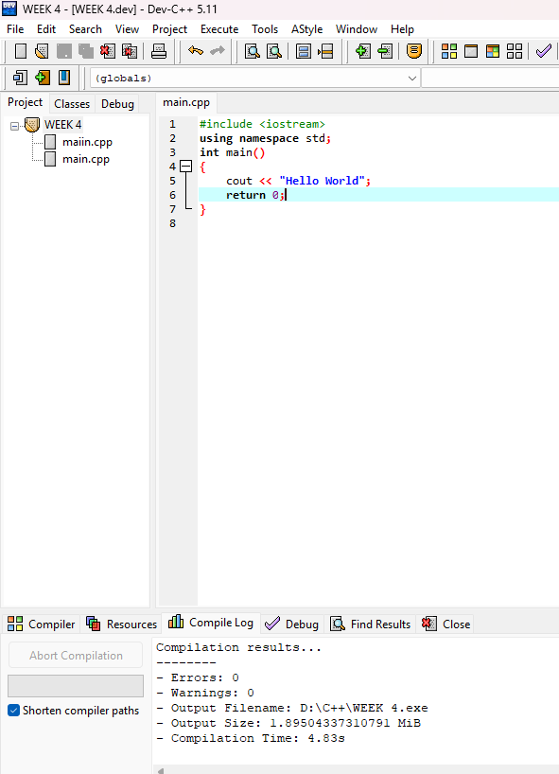
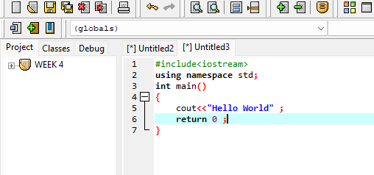
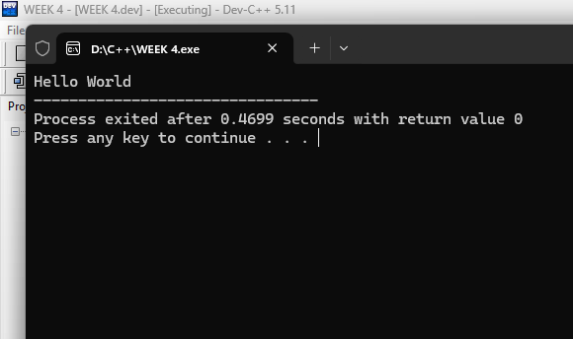

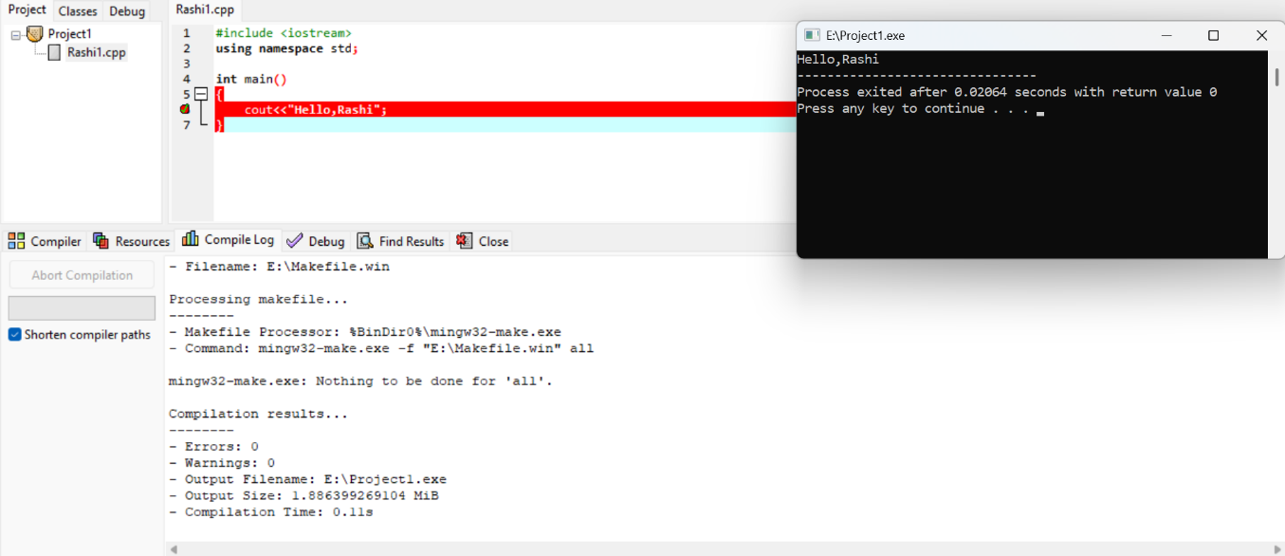
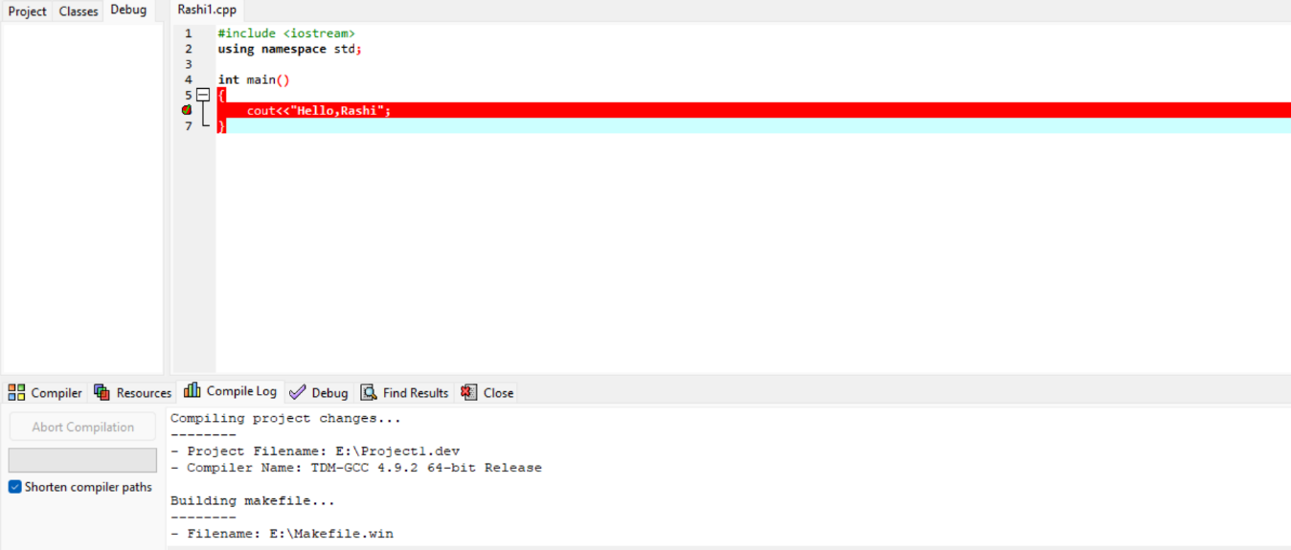
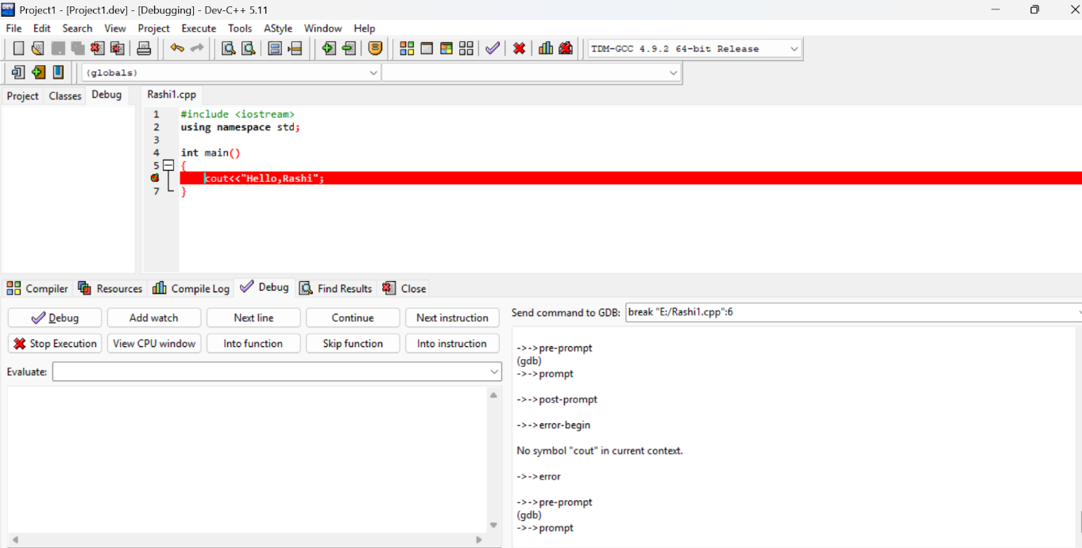

Section 2.01 Step 1: Download Code::Blocks
▶ Go to this website: http://www.codeblocks.org/downloads
▶ Follow the link to ”Download the binary release” (direct link)
▶ Go to the Windows 2000 / XP / Vista / 7 section
▶ Look for the file that includes mingw in the name. (The name as of this writing was
codeblocks-10.05mingw-setup.exe; the 10.05 may be different).
▶ Save the file to your desktop. It is roughly 74 megabytes.
Section 2.02Step 2: Install Code::Blocks
▶ Double click the installer.
▶ Hit next several times. Other setup tutorials will assume you have installed in
C:\Program Files\CodeBlocks (the default install location), but you may install elsewhere
if you like
▶ Do a Full Installation
▶ Launch Code::Blocks
Section 2.03Step 3: Running in Code::Blocks
You will be prompted with a Compilers auto-detection window: When you get the compiler
auto-detection window, just hit OK. Code::Blocks may ask if you want to associate it
as the default viewer for C/C++ files–I’d suggest you do. Click on the File menu, and under
”New”, select ”Project...” The following window will come up: Click on ”Console Application”
and hit the ”Go” button. Click next until you get to the Language Selection Dialog: You’ll be
asked to choose whether you want to use C or C++. If you’re not sure, use C++. Otherwise,
choose based on the language you are learning. After clicking ”Next”, Code::Blocks will then
prompt you with where you’d like to save the console application: I’d recommend you put
it in its own folder, as it may create several files (this is especially true if you create other

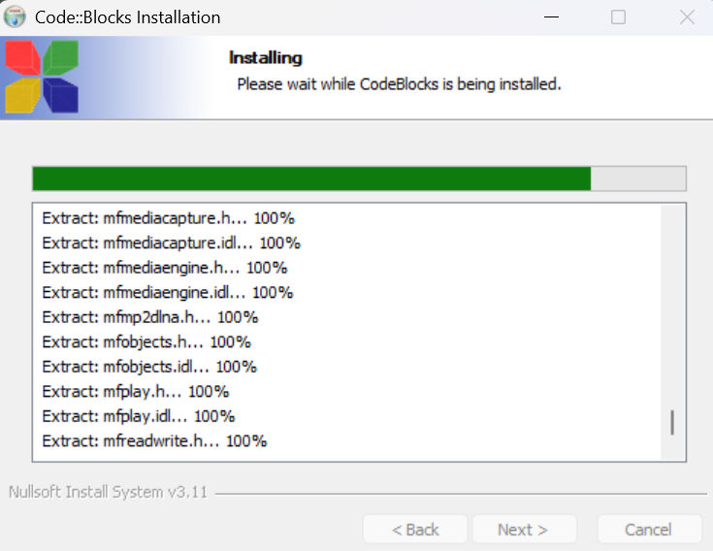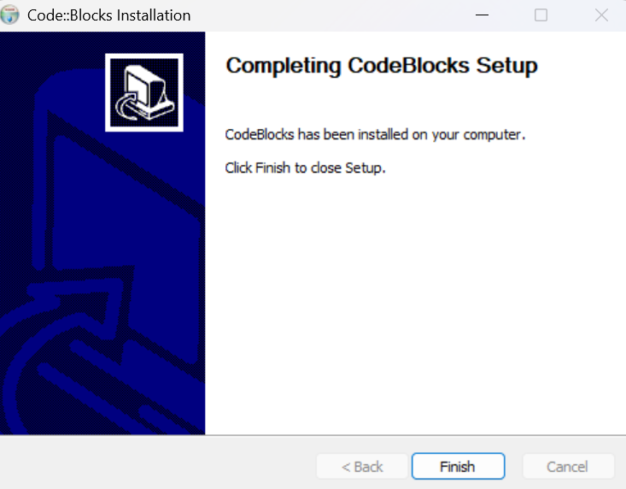

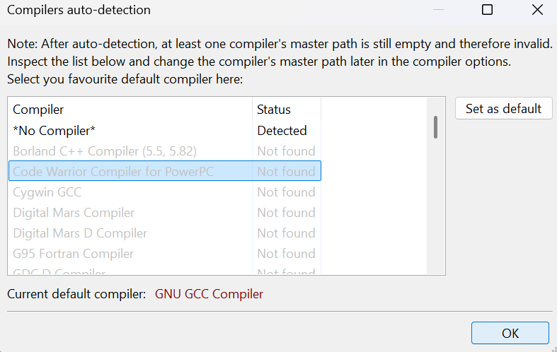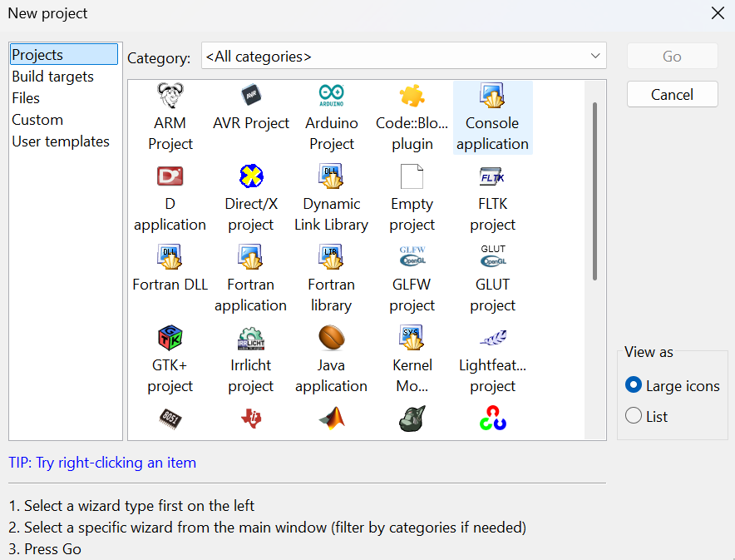

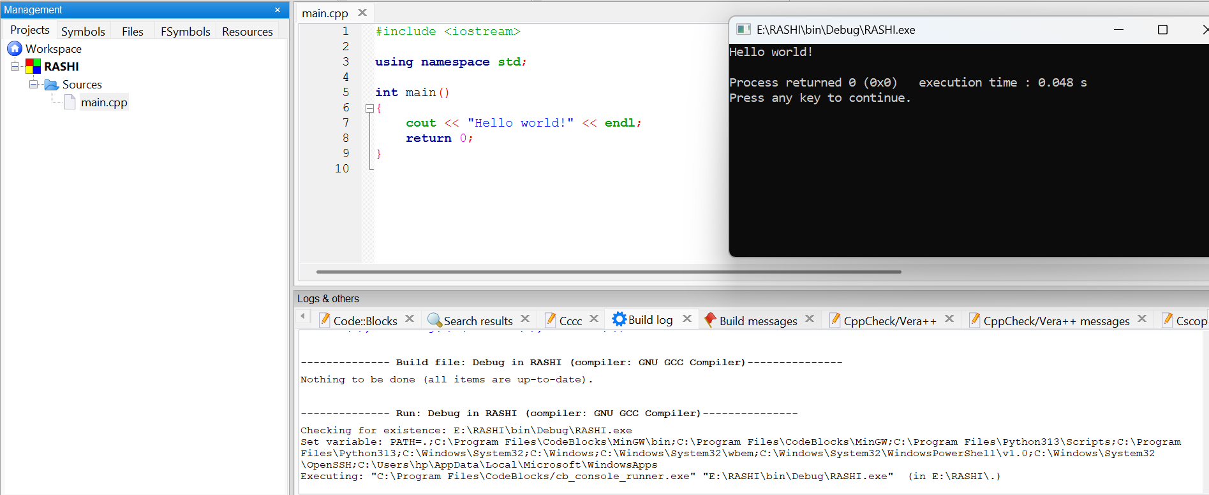

Linux Installation: Install GCC the C++ compiler on Ubuntu 18.04 Bionic Beaver Linux We will install the GNU GCC compiler on Linux. To install and work with the GCC compiler on your Linux machine, proceed according to below steps:
▶ You have to first run the below two commands from your Linux terminal window: This command will install the GCC compiler on your system. You may also run the below command: This command will install all the libraries which are required to compile and run a C++ program.
▶ After completing the above step, you should check whether the GCC compiler is installed in your system correctly or not. To do this you have to run the below-given command from Linux terminal:
▶ If you have completed the above two steps without any errors, then your Linux environment is set up and ready to be used to compile C++ programs. In further steps, we will learn how to compile and run a C++ program on Linux using GCC compiler.
▶ Write your program in a text file and save it with any file name and. CPP extension. We have written a program to display ”Hello World” and saved it in a file with the filename ”helloworld.cpp” on desktop.
g++ filename.cpp -o any-name
g++ helloworld.cpp -o hello
./hello
▶ Now you have to open the Linux terminal and move to the directory where you have saved your file. Then you have to run the below command to compile your file: filename.cpp is the name of your source code file. In our case, the name is ”helloworld.cpp” and any-name can be any name of your choice. This name will be assigned to the executable file which is created by the compiler after compilation. In our case, we choose any-name to be ”hello”.We will run the above command as:
▶ After executing the above command, you will see a new file is created automatically in the same directory where you have saved the source file and the name of this file is the name you chose as any-name. Now to run your program you have to run the below command: This command will run your program in the terminal window.

WEEK #4
C++ Operators, Decision-Making and Control Statements
Problem 1. Write a C++ program to check whether a number is even or odd using ternary operator.
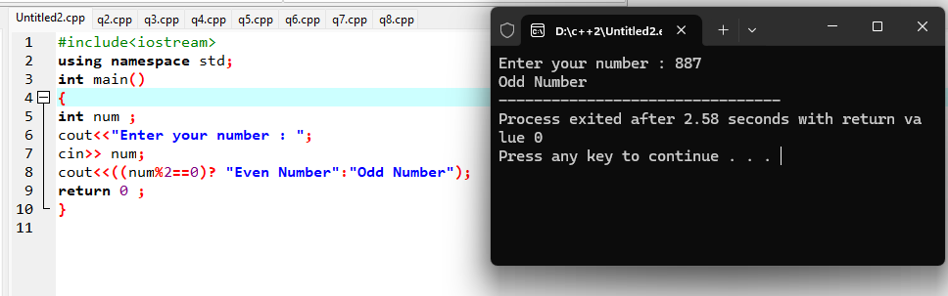
Source Code : Output :

Problem 2. Write a C++ program to perform the addition of two numbers without using + operator.
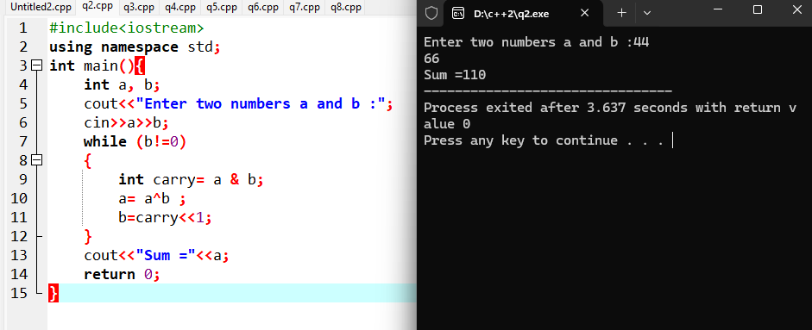
Source code : Output :

Problem 3. Write a C++ program to evaluate the arithmetic expression ((a + b / c * d - e) * (f - g)). Read the values a, b, c, d, e, f, g from the standard input device.
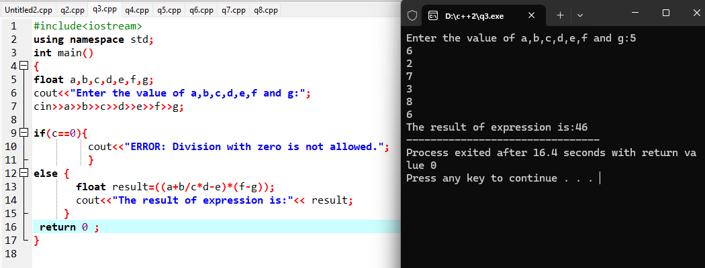
Source Code : Output :

Problem 4. A Fibonacci sequence is defined as follows: The first and second terms in the sequence are 0 and 1. Subsequent terms are found by adding the preceding two terms in the sequence. Write a C++ program to generate the first n terms of the sequence.
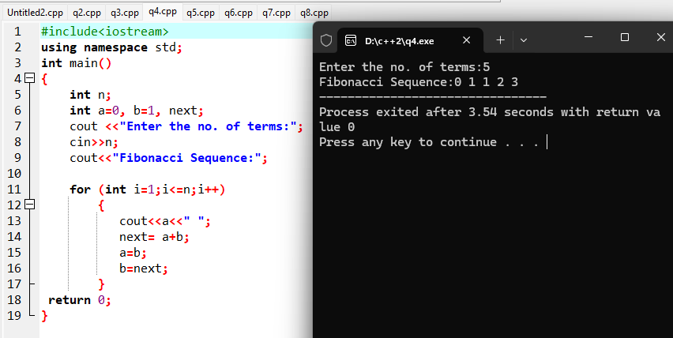
Source code : Output :

Problem 5. Write a C++ program to generate all the prime numbers between 1 and n, where n is a value supplied by the user.
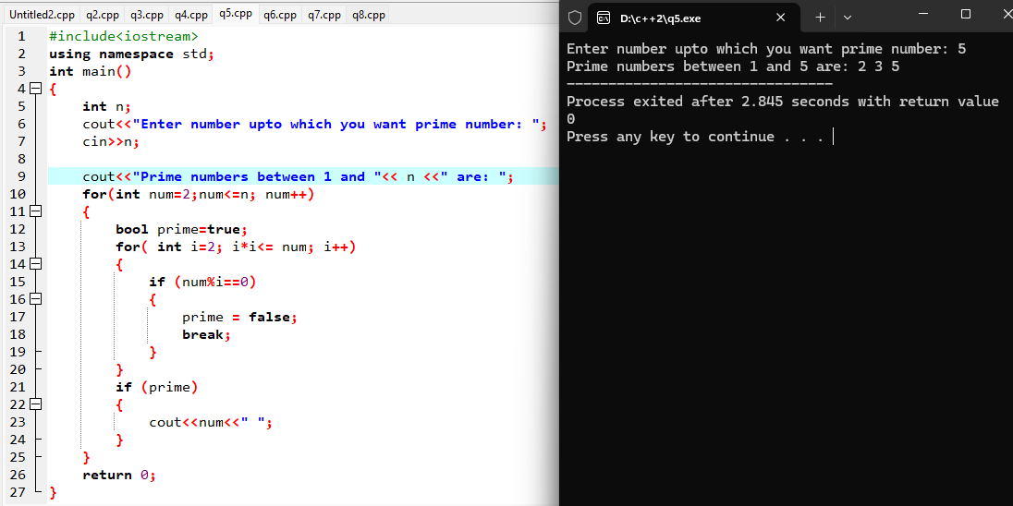
Source code : Output :

Problem 6. A character is entered through keyboard. Write a C++ program to determine whether the character entered is a capital letter, a small case letter, a digit or a special symbol using if-else and switch case. The following table shows the range of ASCII values for various characters. Characters ASCII values A – Z: 65 – 90, a – z: 97 – 122, 0 – 9: 48 – 57 Special symbols 0 – 47, 58 – 64, 91 – 96, 123 – 127.
Source code : Output :
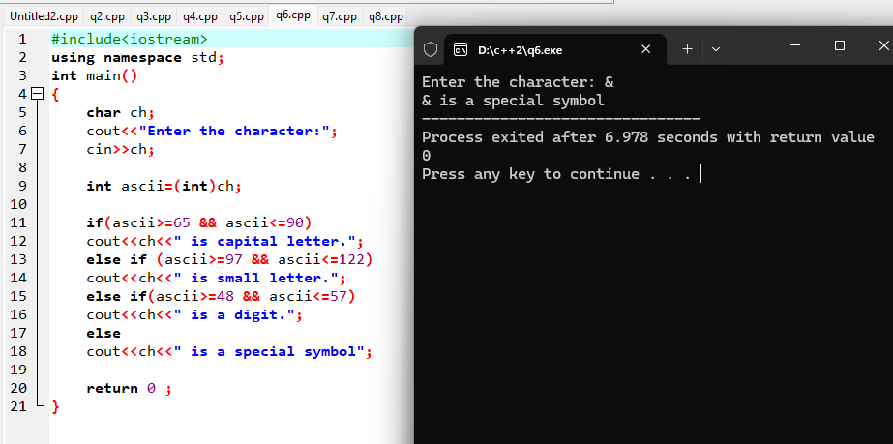
Problem 7. Write a C++ program to find the roots of a quadratic equation.
Source code :
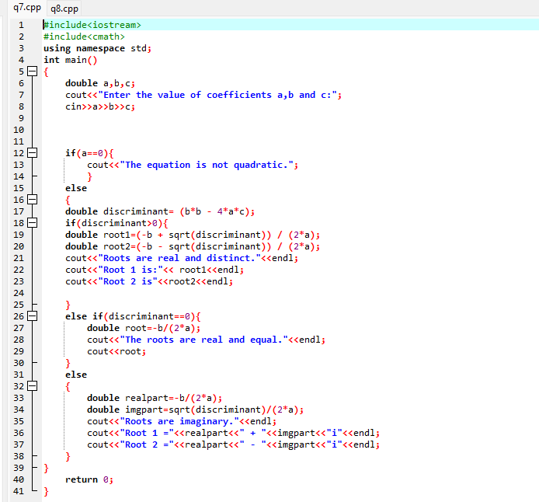
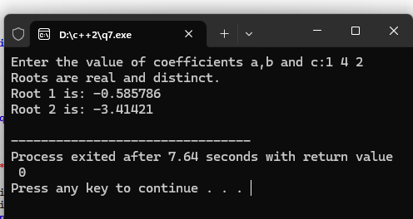
Output :

Problem 8. Write a C++ program to check whether a given 3-digit number is an Armstrong number.

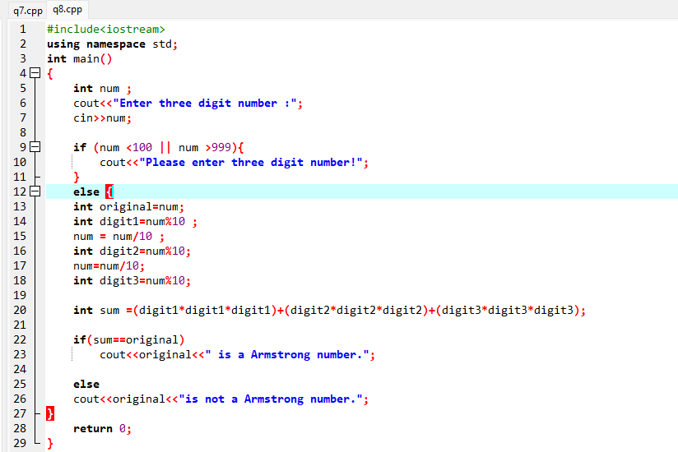
Output :
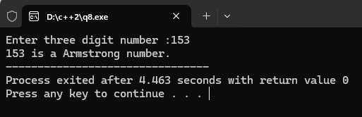

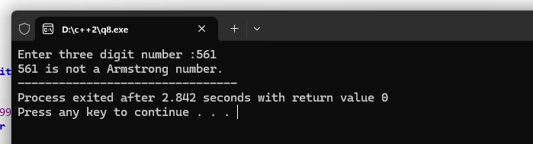
WEEK #5
One- and Two-Dimensional Arrays in C++
Problem 1. Write a C++ program to enter elements in the array and display the array elements.
Source code :
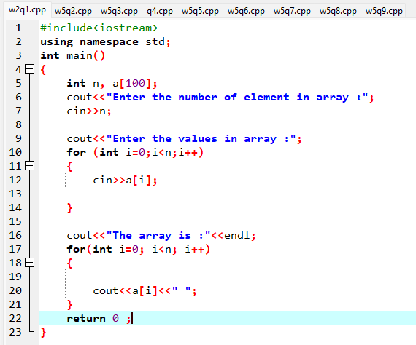
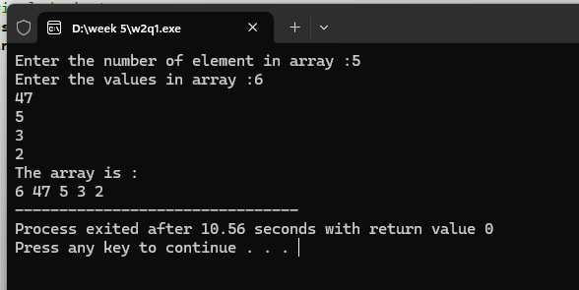
Output :

Problem 2. Write a C++ program to find the sum of all the array elements.
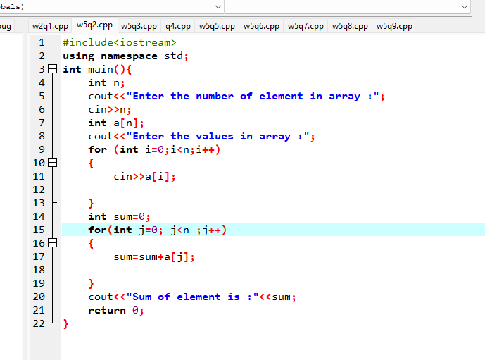
Source code :

Output :
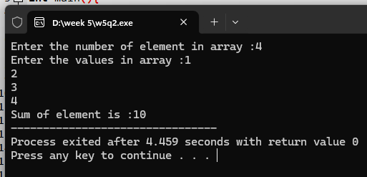
Problem 3. Write a C++ program to find the length of the array.
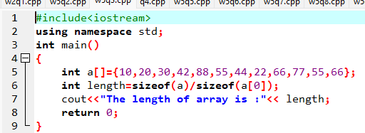
Source code :
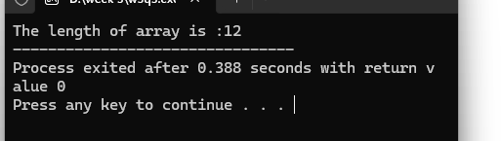
Output:

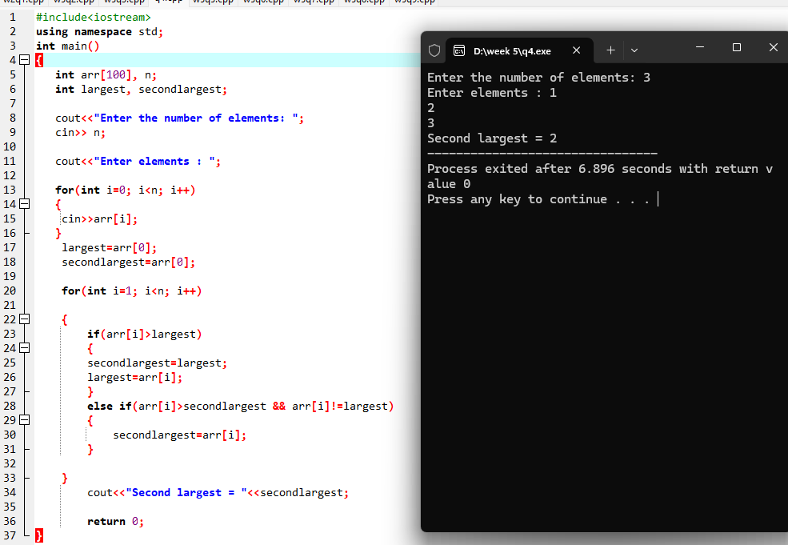
Problem 4. Write a C++ program to find the second-largest integer in a list of integers.
Source code : Output :
Problem 5. Write a C++ Program to reverse the position of the array element (Hint: First element to the last element.)
Source code :
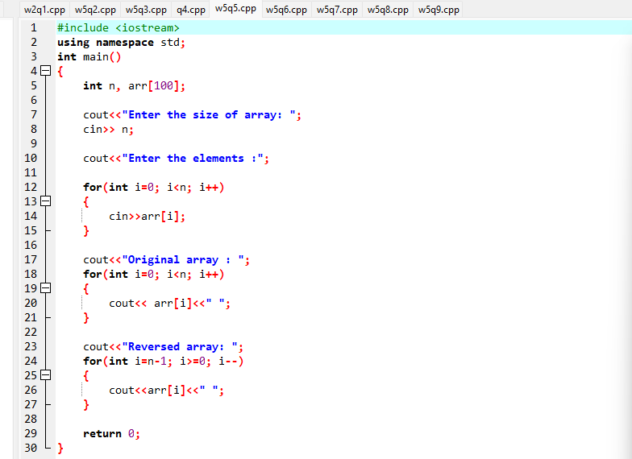
Output :
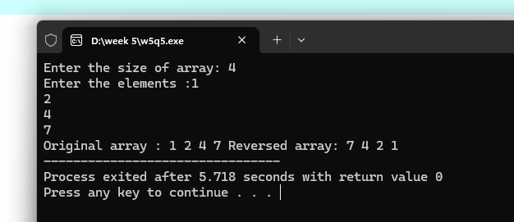

Problem 6. Write a C++ program to perform the following: a. Addition of two matrices b. Multiplication of two matrices.
Source code : Output :
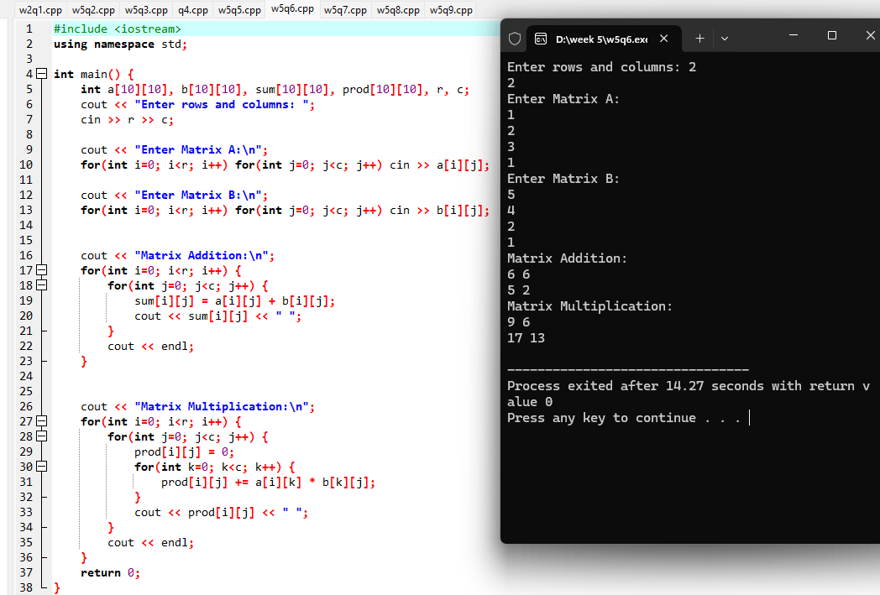

Problem 7. Write a C++ program to count and display positive, negative, odd, and even numbers in an array.
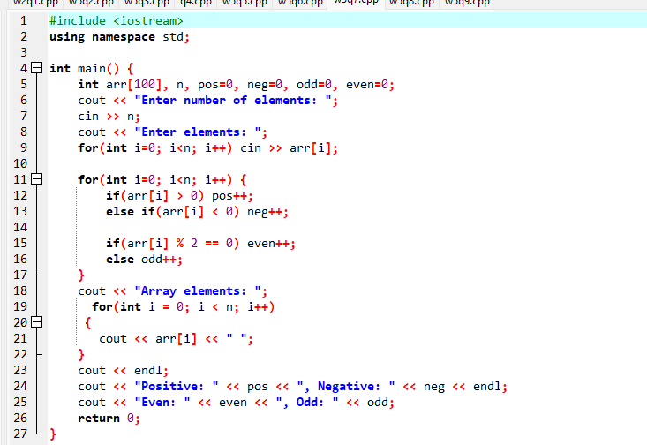
Source code :

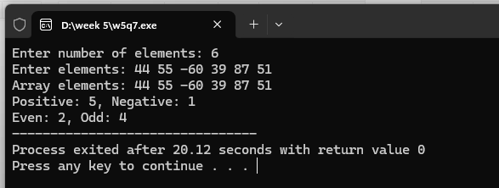
Output :

Problem 8. Write a C++ program to merge two sorted arrays into another array in sorted order.
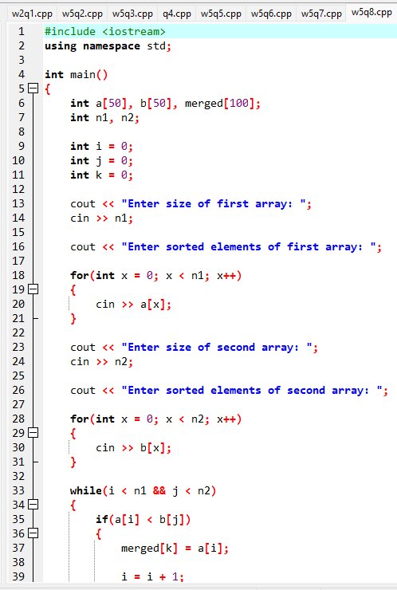
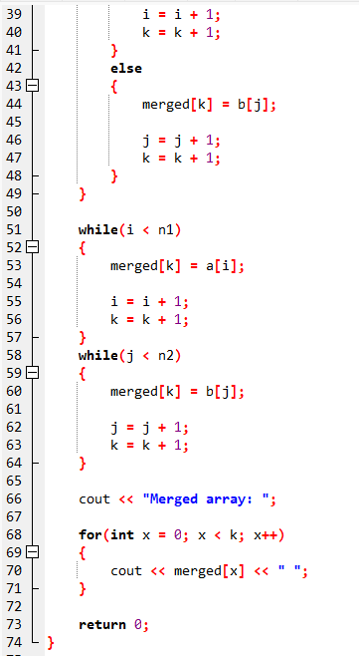
Source code :

Output :
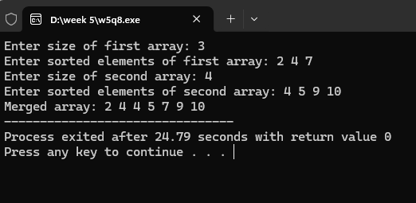

Problem 9. Write a C++ program to find the frequency of a particular number in a list of integers.
Source code :
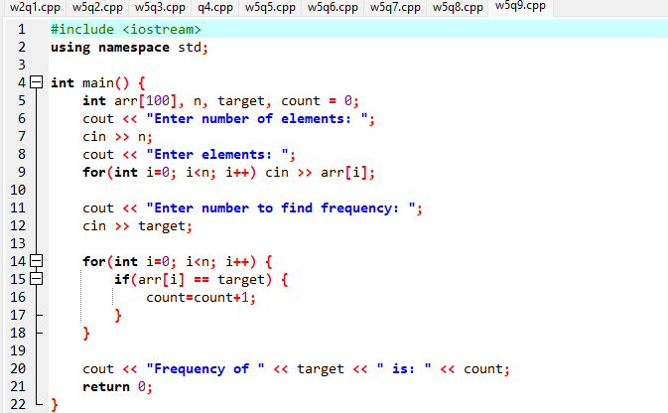

Output :

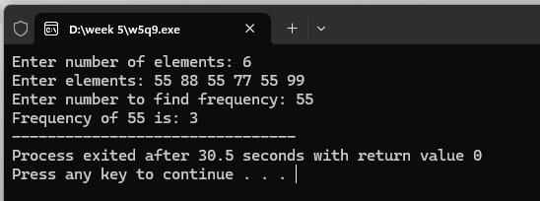

Week #6
Pointers and Pointer Operations in C++
Problem 1. Write a C++ Program to Add Two Numbers Using a Pointer.
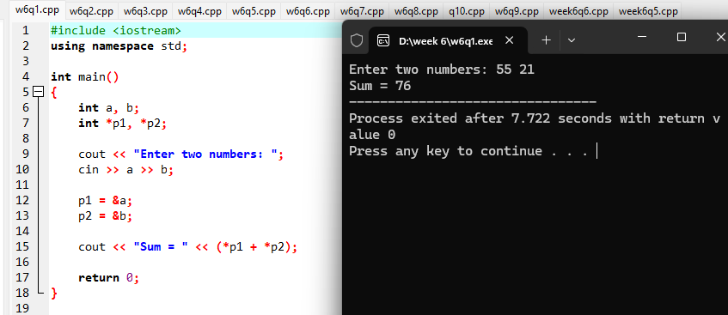
Source code : Output :

Problem 2. Write a C++ Example Program for swapping numbers Using pointers.
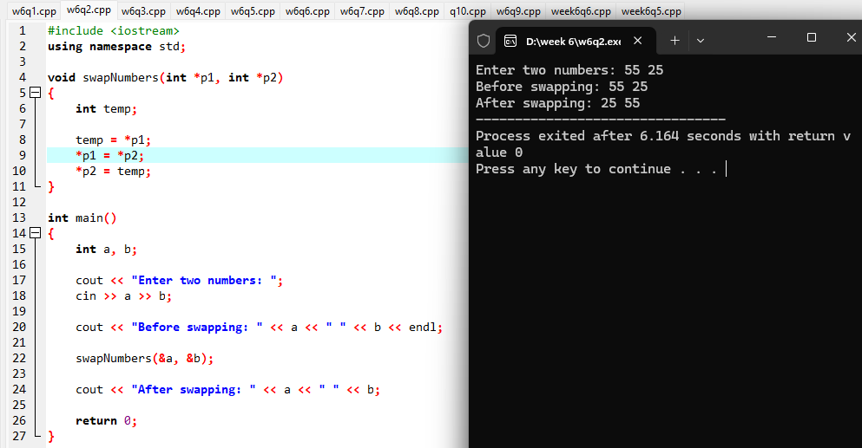
Source code : Output :
Problem 3. Write a C++ Program to print the address of the Variable Using a Pointer.
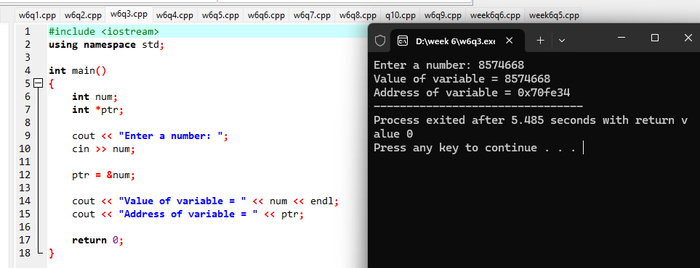
Source code : Output :

Problem 4. Write a C++ Program for Increment and Decrement an Integer Using a Pointer.
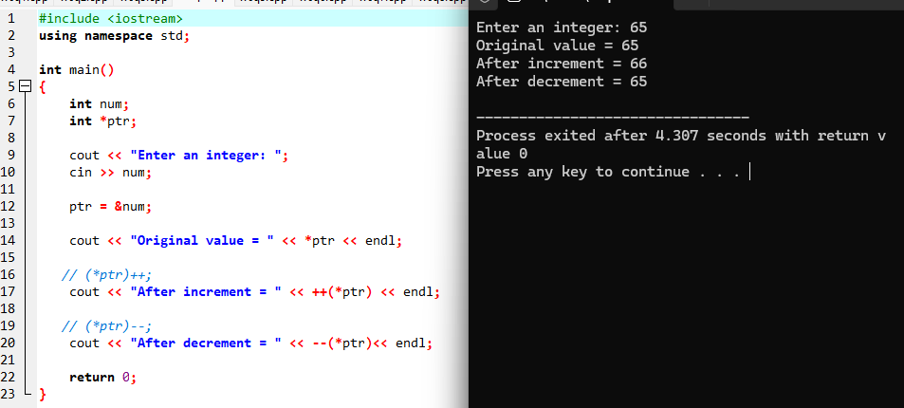
Source code : Output :

Problem 5. Write a C++ Program to Print a String Using a Pointer.
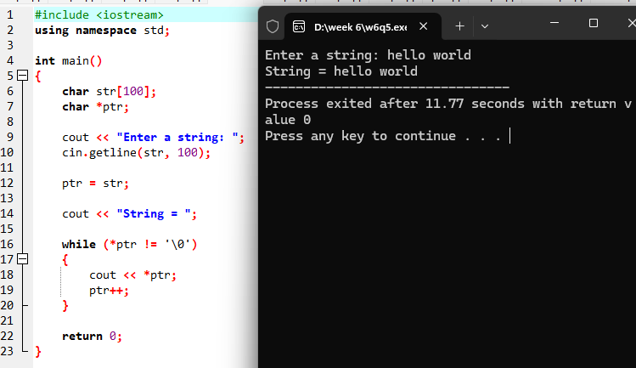
Source code : Output :

Problem 6. Write a C++ program to concatenate two strings using pointers.
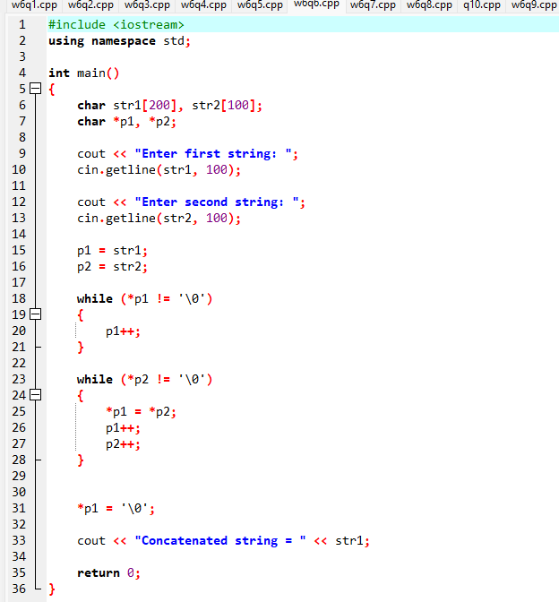
Source code :
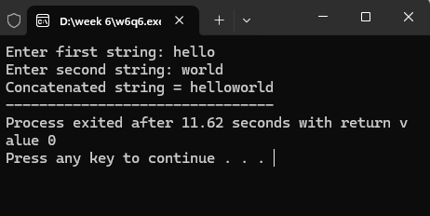
Output:

Problem 7. Write a program for reading elements using a pointer into an array and display the values using an array. i. Declare a set of elements. ii. Declare the pointer and initialize it to the first element’s address of a set of elements(array). iii. Repeat the loop until the pointer reaches to the last element and displays each element.
Source code : Output :
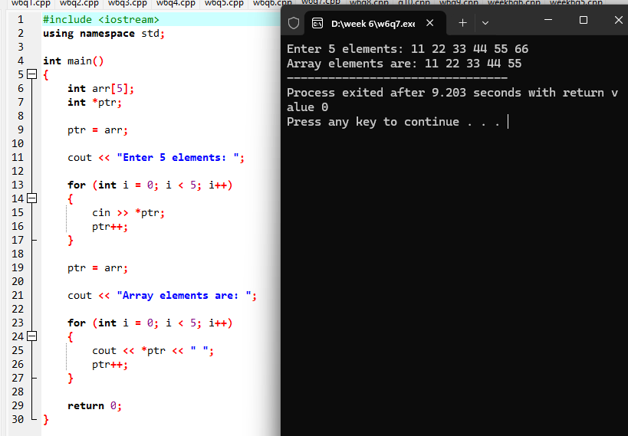
Problem 8. Write a program using a pointer variable to the sum of n elements from the array.
Source code : Output :
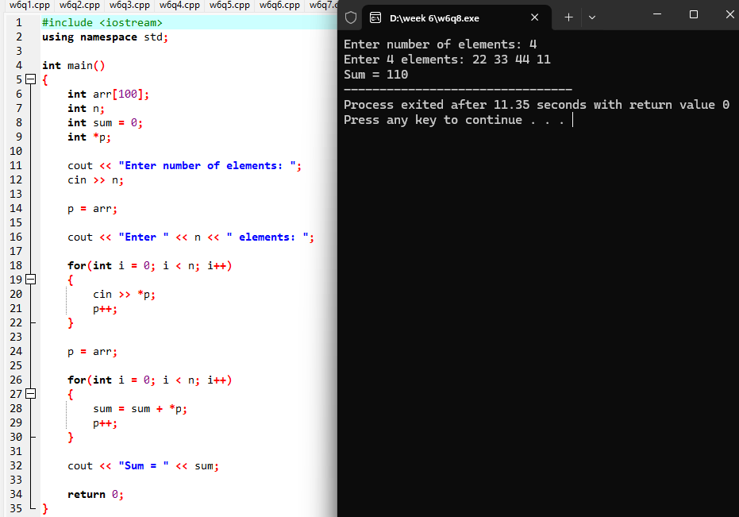

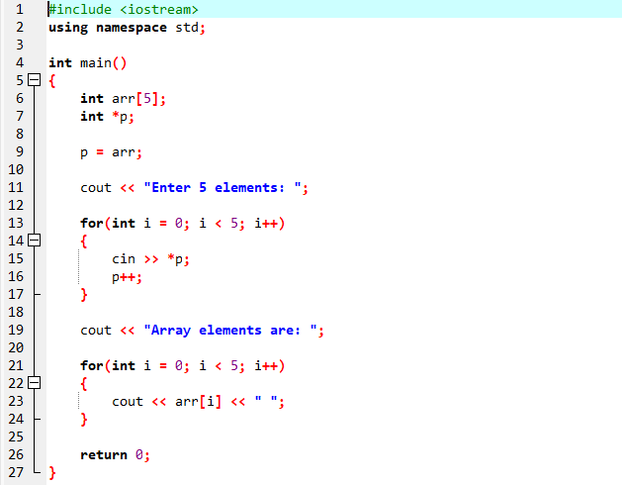
Problem 9. Write a program for reading elements using a pointer into the array and display the values using an array.
Source code :

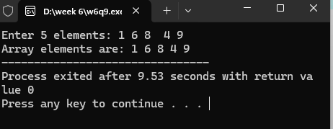
Output :

Problem 10. Write a C++ program to reverse a string using pointers.
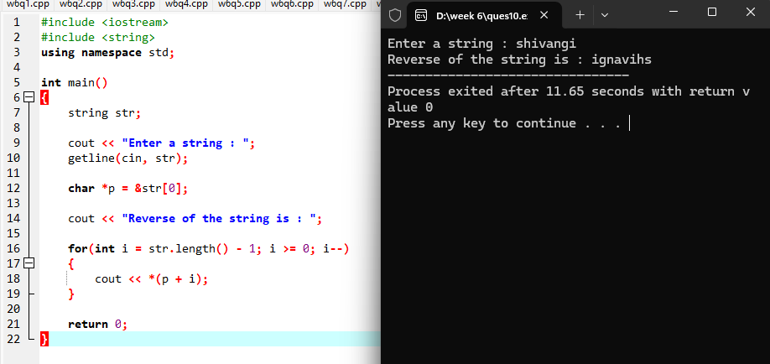
Source code : Output:

